MINISTRY OF EDUCATION, SCIENCE, VOCATIONAL TRAINING & EARLY CHILDHOOD EDUCATION
CHAMA DAY SECONDARY SCHOOL - MUCHINGA PROVINCE
MATHEMATICS DEPARTMENT
GRADE 9B MATHEMATICS QUIZ 1 TERM 1
DURATION: 15 MINUTES MARKS: 10
DATE GIVEN: Monday, 17 February 2014
Answer All The Questions

- Evaluate -8 - (-2). [1]
- Find the Lowest Common Multiple (L.C.M) of 8, 12 and 16. [1]
- If 2x - 5 = -7, then x = ? [2]
- Given that p = -3 and q = 4, find the value of q - 2p. [2]
- Write down the next two terms of the sequence:
1, 4, 2, 5, 3, 6, 4, 7, ……, …… [1]
- 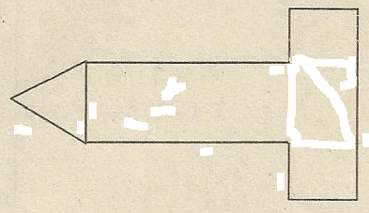How many lines of symmetry does the shape below have? [1]

- How many subsets are in set P, if P = {1, 2, 3}? [1]
- Evaluate $\frac{1}{3}+ \frac{1}{2}$ [1]
- THE END -
"ONLY THE SKY IS THE LIMIT FOR YOU, MY LITTLE BOYS & GIRLS," Eng. F. Chomba

